Here are the codes for all the tables for this assignment.

**Code for department_employee table:**

-- Table: public.department_employee

-- DROP TABLE IF EXISTS public.department_employee;

CREATE TABLE IF NOT EXISTS public.department_employee

(

emp_no character varying(200) COLLATE pg_catalog."default" NOT NULL,

dept_no character varying(255) COLLATE pg_catalog."default" NOT NULL

)

TABLESPACE pg_default;

ALTER TABLE IF EXISTS public.department_employee

OWNER to postgres;

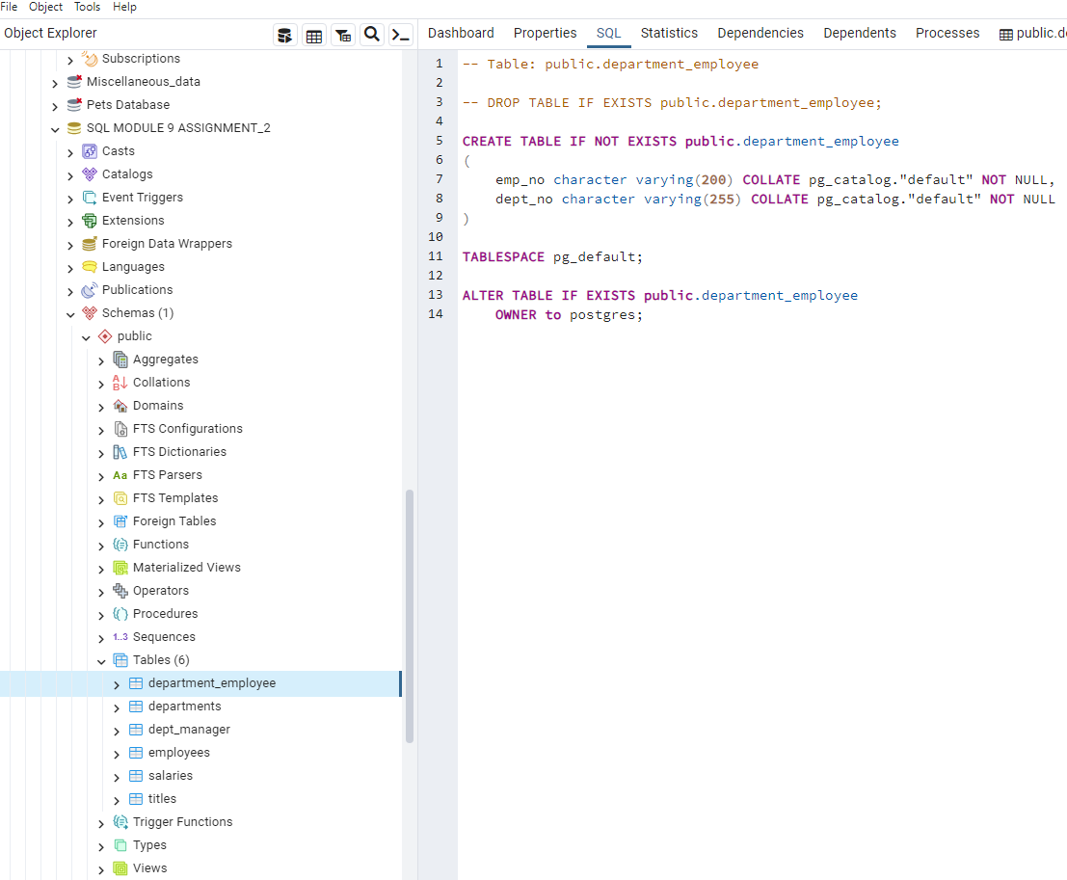

**Code for departments table:**

-- Table: public.departments

-- DROP TABLE IF EXISTS public.departments;

CREATE TABLE IF NOT EXISTS public.departments

(

dept_no character varying(100) COLLATE pg_catalog."default" NOT NULL,

dept_name character varying(255) COLLATE pg_catalog."default" NOT NULL,

CONSTRAINT pk_departments PRIMARY KEY (dept_no),

CONSTRAINT unique_dept_name UNIQUE (dept_name)

)

TABLESPACE pg_default;

ALTER TABLE IF EXISTS public.departments

OWNER to postgres;

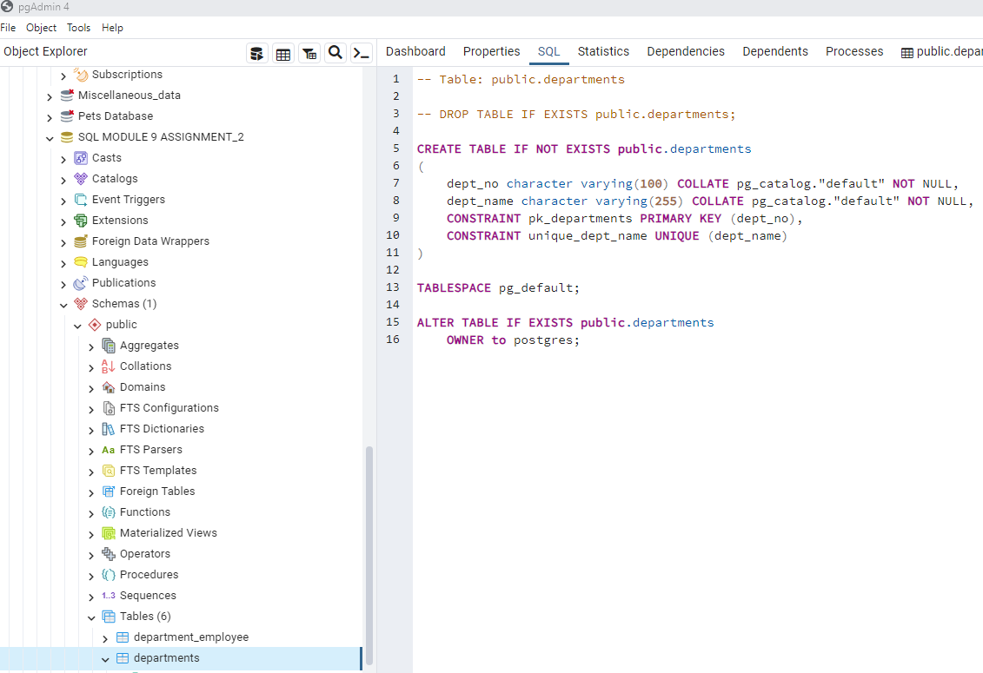

**Code for dept_manager table:**

-- Table: public.dept_manager

-- DROP TABLE IF EXISTS public.dept_manager;

CREATE TABLE IF NOT EXISTS public.dept_manager

(

dept_no character varying(255) COLLATE pg_catalog."default" NOT NULL,

emp_no integer NOT NULL,

CONSTRAINT dept_manager_pkey PRIMARY KEY (dept_no, emp_no)

)

TABLESPACE pg_default;

ALTER TABLE IF EXISTS public.dept_manager

OWNER to postgres;

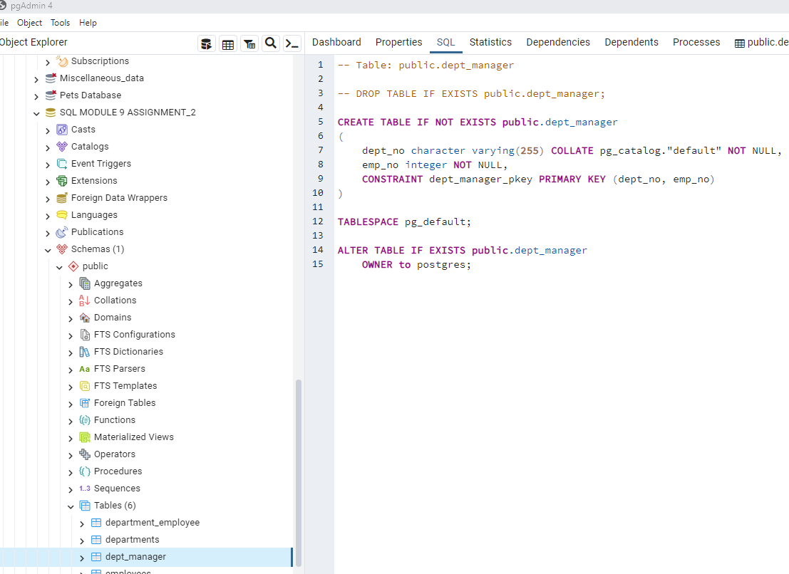

**Code for employees table:**

-- Table: public.employees

-- DROP TABLE IF EXISTS public.employees;

CREATE TABLE IF NOT EXISTS public.employees

(

emp_no integer NOT NULL,

emp_title character varying(255) COLLATE pg_catalog."default",

birth_date date NOT NULL,

first_name character varying(255) COLLATE pg_catalog."default" NOT NULL,

last_name character varying(255) COLLATE pg_catalog."default" NOT NULL,

sex character(1) COLLATE pg_catalog."default" NOT NULL,

hire_date date NOT NULL,

CONSTRAINT pk_employeenames PRIMARY KEY (emp_no),

CONSTRAINT employees_sex_check CHECK (sex = ANY (ARRAY['M'::bpchar, 'F'::bpchar]))

)

TABLESPACE pg_default;

ALTER TABLE IF EXISTS public.employees

OWNER to postgres;

**Code for salaries table:**

-- Table: public.salaries

-- DROP TABLE IF EXISTS public.salaries;

CREATE TABLE IF NOT EXISTS public.salaries

(

emp_no integer NOT NULL,

salary character varying(100) COLLATE pg_catalog."default" NOT NULL,

CONSTRAINT pk_salaries PRIMARY KEY (emp_no),

CONSTRAINT fk_salaries_emp_no FOREIGN KEY (emp_no)

REFERENCES public.employees (emp_no) MATCH SIMPLE

ON UPDATE NO ACTION

ON DELETE NO ACTION

)

TABLESPACE pg_default;

ALTER TABLE IF EXISTS public.salaries

OWNER to postgres;

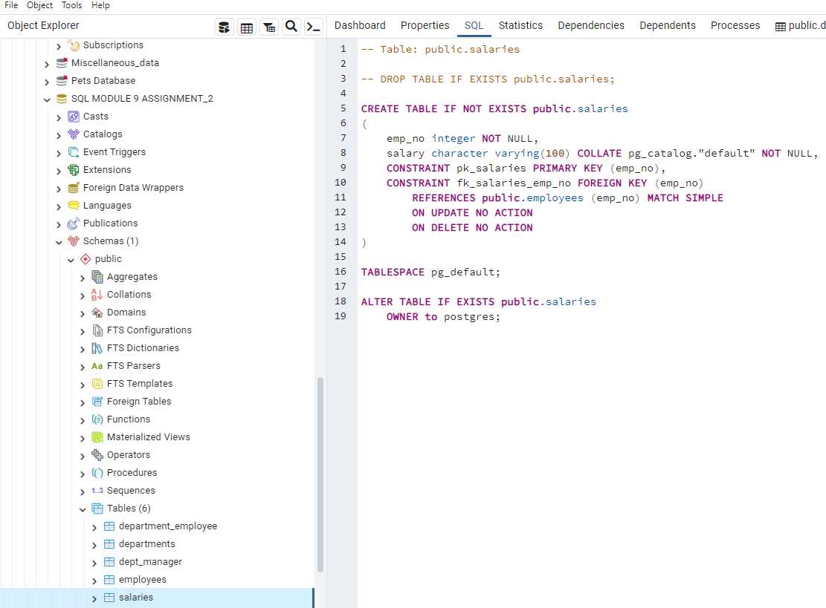

**Code for titles table:**

-- Table: public.titles

-- DROP TABLE IF EXISTS public.titles;

CREATE TABLE IF NOT EXISTS public.titles

(

title_id character(5) COLLATE pg_catalog."default" NOT NULL,

title character varying(255) COLLATE pg_catalog."default" NOT NULL,

CONSTRAINT pk_titles PRIMARY KEY (title_id)

)

TABLESPACE pg_default;

ALTER TABLE IF EXISTS public.titles

OWNER to postgres;

